High pressure hose & Discharge hose

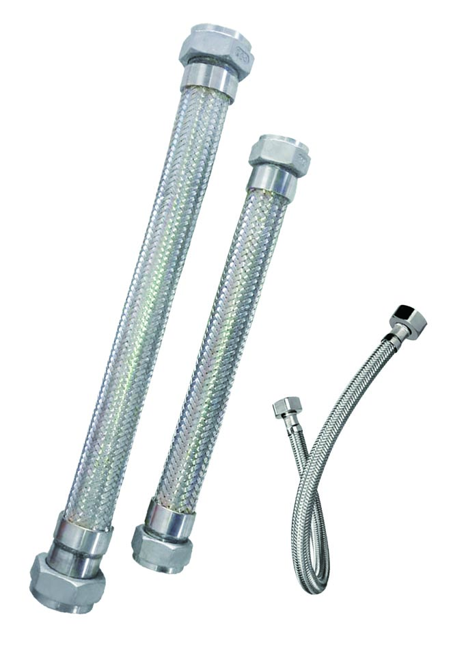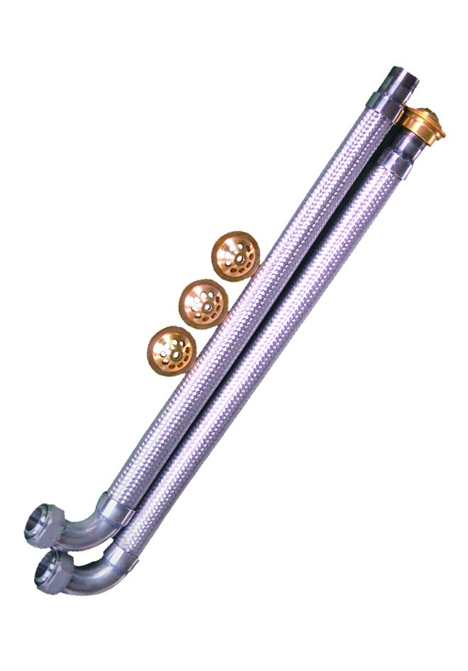

1 Overview
The net system high pressure hose is connected between the fire extinguisher container valve and the manifold, and delivers the extinguish agent in the fire extinguisher cylinder to the manifold.
The cabinet system discharge hose is connected between the fire extinguisher container valve and the nozzle on the cabinet, and deliver the extinguish agent in the fire extinguisher cylinder to the protected area.

2 Technical Parameter
The net system high pressure hose

Model | Nominal diameter | Connect thread | Nominal working pressure
QRG32/8 | 32 | M48*2 | 8MPa
QRG40/8 | 40 | M60*2 | 8MPa
HRG16/17.2 | 16 | M27*1.5 | 17.2MPa

The cabinet system discharge hose
Model | Nominal diameter | Connect thread | Nominal working pressure
QRG32 | 32 | Rc³/₈‘’ | 5.3MPa
QRG40 | 40 | Rc³/₄‘’ | 5.3MPa

